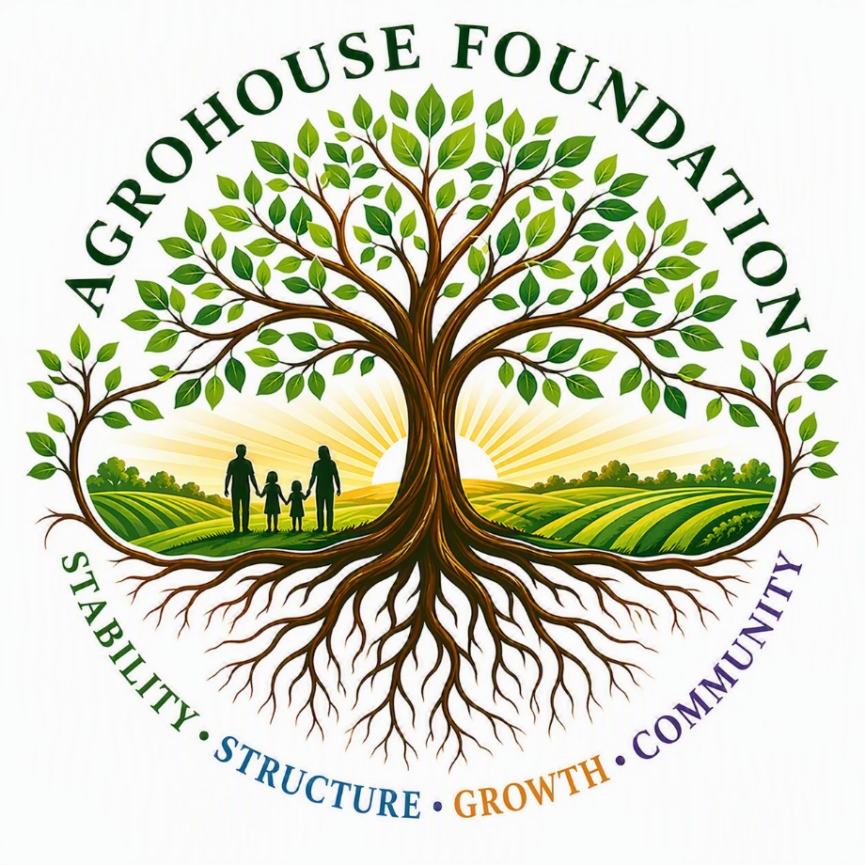

AgroHouse Foundation™
Guided Site Walkthrough
Campus Layout and Operational Experience
Prepared by: Maggie Baty, Founder of AgroHouse Foundation

Welcome Letter
Thank you for taking the time to visit AgroHouse Foundation™. This guided walkthrough is designed to give you a firsthand feel for the future campus that is AgroHouse Foundation™, as if you were physically moving through it step-by-step, rather than reading about it in the abstract.
This document focuses specifically on the physical design of the campus and farm systems, including:
- How the property is laid out from north to south
- How people, food, and materials move through the property
- How different environments are separated and connected
- Where supervision, access control, and safety systems are built into the design
It is meant to be read as an experience, so you can get a feel for how the system functions as a whole.
At this stage, this walkthrough reflects the build-out and structural design only. Workforce, education, and training program details are developed and presented separately. Security gates and cameras are designated throughout the property in the appropriate locations.
As you go through this walkthrough, we welcome your thoughts on:
- The overall structure of the environment
- How movement and boundaries are defined
- The balance between supervision and personal space
- The interaction between residential, public, and operational areas
There's a lot here, so there's no expectation to absorb everything at once. This is simply meant to give you a clear picture of the property before we meet in person. Thank you for taking the time to look it over, and we look forward to walking you through it.
Sincerely,
Maggie Baty
Founder, AgroHouse Foundation™

Contents
1. Welcome Letter
2. The North Side Guided Walkthrough
3. The South Side Guided Walkthrough
4. The FlowerBerry Corridor
5. Livestock Education Path — Cattle, Swine, Waterfowl, and Pigeons

The North Side Guided Walkthrough
The guided tour begins once you leave through the back door of the main office building of the AgroHouse Foundation™ facility. There is one path that runs straight south through the north compound. Around you are other walking and running paths with benches scattered along the way, sprinkled with beautiful flowers, fruit trees, greenery, and pollinator stations.
On the left side of the path, separated by fencing, are two male AgroHouses™, and on the right are two female AgroHouses™. Each AgroHouse™ has its own living space with an attached one-acre hoop house for learning and working their own crop systems. The AgroHouse™ is a vocational housing system that provides education and training. Residents actively learn the skills necessary for growing, maintaining, and harvesting fruits and vegetables, and are required to complete workforce training through either culinary education or by selling fruits and vegetables to the public at the farm stand.
The food grown on the property serves several purposes: it brings revenue back into the nonprofit, feeds the residents of the program, and is distributed to outreach programs as prepared meals and food boxes for those experiencing homelessness.
As you continue along the path, you'll pass a small basketball court, a horseshoe area, a small recreation field for tossing footballs or playing soccer, and a playground used by AgroHouse™ residents for socializing and family reunification.
As you proceed south along the path, you approach a biosecurity barrier — the point that separates the residential and public side of the property from the vegetable production side. At the barrier, the guide explains what the barrier is, where you'll see similar barriers throughout the tour, and why it's necessary to wash boots or use booties over your shoes before continuing.

The South Side Guided Walkthrough
Booties on, boots washed, entry through the biosecurity barrier opens into the north edge of the working farm. Everything here is designed to be both productive and visually instructive, so as you step onto the defined educational path, you're immediately surrounded by structured growing systems.
On one side, you see organized raised-bed crop systems used for vegetables and greens. These beds are neat, repeatable, and clearly maintained, showing how food is grown in a controlled, teachable way rather than scattered across open land. Beyond the raised systems are deeper crop areas, where root crops and seasonal plants like melons and pumpkins are arranged in longer rows. Nothing here is random or unplanned.
As you continue forward, the path opens into our intentionally designed FlowerBerry Corridor.

The FlowerBerry Corridor
On one side of the path is a corridor of strawberries, blueberries, blackberries, and raspberries. Visitors are handed a small basket and invited to taste, pick, and connect directly with the berries. On the other side is a beautiful spread of sunflowers of varying heights that line the edge of the path, and beyond that, rows of corn create a layered effect — a living wall of color, height, and movement.
The guide explains how sunflowers grow and how they follow the sun as it moves throughout the day. If the flowers are in full bloom, visitors are invited to pick one on their way back to the North Campus.
The path continues to another biosecurity barrier and boot-wash station. The guide explains that everything inside this next area involves animals, manure systems, and controlled environments, and that entry and exit are never casual — everything is intentional.
Livestock Education Path — Cattle, Swine, Waterfowl, and Pigeons
Once properly prepared, you step through the barrier and enter a different environment. The first stop is the cattle area, where you'll observe cattle grazing, sunning, or cooling off in the water. The guide explains how grazing is managed, how movement is controlled, and how these systems support production.
As you continue, you'll transition into the swine area and observe the feeder pigs at play. The guide points out how structure keeps both animals and people safe. Around the next curve, the path opens into an area with picnic tables, where visitors can enjoy water and a snack grown and harvested on the farm while listening to the sound of a waterfall and watching the geese and ducks in their habitat, or catching an aerial display of roller pigeons in flight.
The guide gives a short lesson on goose behavior and how the geese and pond help fertilize the crops in the early stages of growing. From there, the tour transitions from waterfowl observation into the Poultry Systems.
The guide leads you to a handwashing and boot-washing station to once again wash hands and boots, or change booties if necessary, before continuing to the incubation station and brood houses. Here you can observe chicks with their mothers, hens teaching chicks to eat and drink, or look through an observation window to learn about incubation and see trained staff caring for newly hatched chicks and eggs in various stages of hatching.
The guide takes you around the last curve to a stretch of small chicken houses where breeders and feeder chickens roam and forage freely, and will walk you through everything about chickens before transitioning into the final livestock area — a hands-on zone featuring Jersey Giants, Leghorns, and Plymouth Rocks.
The guide explains that interaction is allowed only with chickens that can be caught safely; otherwise, visitors observe from a distance. This reinforces both control and respect for the animals, while still allowing guests to interact with some of the gentlest and most docile breeds on the farm.
After a chance to interact with the chickens, visitors come to a handwashing station (used only if chickens were handled) before being given the option to step into a teaching pen for a more hands-on learning experience, or to visit the goat playground, where goats jump, play, and headbutt for attention.
After time in the teaching pens or with the goats, you're guided back through the same barrier you entered from, washing hands, boots, or changing booties once more to transition back into the crop zone. Visitors are invited to pick a sunflower on the way back before walking through the final barrier into the North Campus, where the tour concludes at the farm stand — where guests can purchase organic fruits and vegetables grown at AgroHouse Foundation™.

